Vanessa Jackson

Dr. Caton-Garcia

English 1102

23 April 2018

The Wacky World of Racism: A Critical Look into the Cultural Significance of Cartoons

Cartoons may seem silly and insignificant, but growing up with them, animation in general has always had a special place in my heart, to say the least. I appreciated the work that went into animation, whether it be ten minutes short to 2 hours long. There was always something special to the idea of moving pictures, I am not the only viewer fascinated by this artform. I remember scenes from *Toy Story, Looney Toons, The Flintstones, The House of Mouse,* to name a few, and to this day, their theme songs and dance numbers still worm their way into my ear and play in my head. To know that my favorite creators like Walt Disney and Warner Bros. have a racist past is a truth that slowly unfolded itself like a pop-up book.

Determined to venture more into the history, I considered my fascination with cartoons, and my newly found aspirations of being a writer and a voice actor. I was already aware of the basic history of racial depictions in old-timey cartoons, but I never focused on their significance; at least, until this essay. Generally speaking, *yeah sure, this is racist, but it’s not made today.* From there I asked, *Sure, this is racist, but I wonder what we can learn from our racist past?* From researching this essay, one can conclude that the cultural significance of these cartoons isn’t to just admit its racist features, but rather, laugh at the idea of racial ignorance. Critically delving into the world of racist cartoons from society’s past can give modern creators and viewers objective, significant insight on the production and perception of modern cartoons.

Animation is the process of creating movement in still images. It has been around for about half a century. Since the development of cinema, creators began to experiment with the visual effects of screenplay. The invention of the phenakistoscope and the zoetrope began the exponential growth of the animation industry (Kehr). From there, more and more artists experimented with animation, and developed major names for themselves and their works, including Émile Cohl (*Fantasmagorie,* 1908), J. Stuart Blackton, (*Humorous Phases of Funny Faces*, 1906), Winsor McCay (*Gertie the Dinosaur,* 1914), Eadweard J. Muybridge (*Waltzing Couple*, 1893) Max and Dave Fleischer, Walt Disney, and Warner Brothers (consisting of Rudolph Ising, Hugh Harmon, and Friz Freleng) (Popova). From then on, the animation industry began to establish its popularity in mainstream discussion, and in other countries around the world including Asia and Europe, ultimately making it into the popular contemporary art style in media we have today.

Unfortunately, animation wasn’t always about silly faces, happy dinosaurs, clever rabbits, or fairy tales. Before analyzing the animated works, it is important to not only acknowledge the history of the animation industry, but to recognize the historical context of each piece being investigated. This includes things like the artist’s personal life, surrounding wars, social politics, and the like. Art itself reflects the observations of the artis~~t.~~ Two people, regardless of gender, race, or religion, can have very two different perspectives on the same subject, and thus create different pieces of art, with different intentions. Admitting this context means that the cartoons in question are not only a reflection of the time but contain a deeper meaning that can be extrapolated and applied to modern day animation.

External current events like World Wars, and social politics (like racism and sexism), began to present itself in the artform. As the technological evolution and mainstream prevalence of the animation industry began to cultivate in full force, cartoons, whether aimed at children or adults, became a format of propaganda. For example, Dr. Seuss began his art career as a satirical commentator of current politics; he wrote for newspapers but before his jump into the “children’s book field”, he was mostly known for his political and pop-cultural cartoons (Marschall 9-14). Even his more recent children’s stories have subtle political messages. His art was inspired by events like World War I and II and Pearl Harbor. His older work, which was, for the most part, rooted in anti-racism, still projected scornful opinions about the United State’s relationship between countries like Germany and Japan, especially in times of battle; in an article from *The Atlantic,* Sophie Gilbert writes,“It’s more than a little baffling now to see Geisel, who’d railed repeatedly against racism, Jim Crow, and anti-Semitism in his cartoons, proffer up such bigoted depictions of Asians both in the U.S. and overseas.” (Gilbert). Although the pieces created by writers like Dr. Seuss, Walt Disney, and Warner Brothers are reflections of the political landscape at the time, they are not excuses for negative racial representation. Being able to recognize the historical influence the authors when creating their cartoons is a first step in understanding the real reasons as to *why* these cartoons are offensive. Once we examine that, it’ll be clearer to extrapolate an objective meaning from them, and they be able to apply that knew knowledge to current cartoons.

Figure 3 Mickey and Minnie Mouse had their fair share in minstrel shows, like in Walt Disney's 'Mickey's Mellerdrammer', produced and presented in 1933

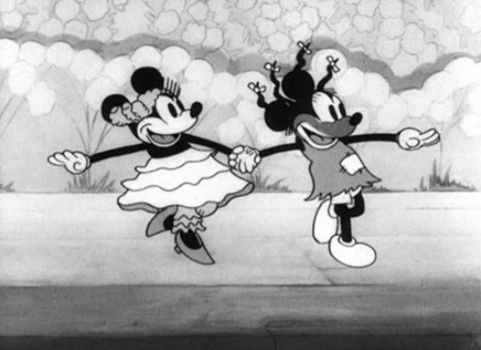Dr. Seuss is just one of many writers who built stories and concepts with the use of human characters. More specifically, cartoon’s influence on society was the development of human characters shown in cartoons, like those who interacted with Bugs Bunny and Tom & Jerry. The influence of creating more human characters rather than animals was to develop a connection between audience and fictional world. Making human characters like *Betty Boop and Popeye, meant that the audience can relate to them more closely. But not everyone had a positive connection with themselves and their cartoon representative on the screen.* The creation of people-centric cartoons came with the creation of racial caricatures, used to demean racial minorities with distorting imagery; Blacks, Asians, Mexicans, and Native Americans, to say the least, were full of negative characteristics, while their white cartoon co-actors were well-kept, polite, and civilized. After the abolishment of slavery in the United States, Blacks and other racial minorities were still being oppressed. Jim Crow laws, were developed “After the American Civil War (1861-1865), [and] most southern states and, later, border states passed laws that denied blacks basic human rights. ‘Jim Crow’ became a kind of shorthand for the laws, customs and etiquette that segregated and demeaned African Americans primarily from the 1870s to the 1960s.” (Ferris State University's Jim Crow Museum of Racist Memorabilia). A lot of the current events at the time, like Jim Crow and segregation, did inspire society’s most popular characters, like Mickey Mouse and Felix the Cat, whose visual details were inspired by vaudeville actors who performed in blackface. There are episodes circulating the internet, including *‘Mickey’s Mellerdrammer*, where Mickey performs in blackface with his supporting characters.

In more people-centric episodes, African-Americans, and several other racial minorities in the United States, were portrayed as animalistic, violent, unintelligent, and lazy; *All This and Rabbit Stew, Jungle Jitters,* and *Scrub Me Mamma with a Boogie Beat* are all examples of African-American representation in cartoons during the 20th century. The caricatures of Blacks and Africans were very diverse. “The Mammy” archetype, is an overweight, unattractive, woman who enjoyed her position as a slave to her white family. “The Cannibal,” usually antagonists in African countries, is selfish and animalistic, and who needs the help of a ‘smart guy’ to show them the ‘civilized way.’ “The Coon,” a general statement used to describe an idiotic black man whose naïveté makes him the butt of every joke. “The Picaninny” is a young child, often neglected and unkempt, of either gender, who is clever enough to get themselves out of trouble, but dumb enough to justify poor treatment from whites. (Ferris State University's Jim Crow Museum of Racist Memorabilia). These are only a couple of the archetypes used to disregard the humanity of African-Americans. It is one thing to draw exaggerated features on characters to create a sense of silliness and innocence to a cartoon character (like ‘the Rubber Hose’ animation style, a format using circles and rounded shapes rather than sharp points), but it is something entirely 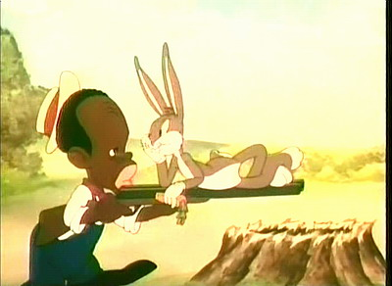different to exaggerate features with a negative intent. The visual exaggeration of physical features like thick lips, bulbous white eyes, large foreheads and nappy hair, is used to not only mock blacks, but to justify ridicule and disdain towards them in media and real life. These stereotypes (either created by the media to influence society or created by society that influenced the media’s content) is based on pseudoscientific evidence about racial superiority; In an article from *The Guardian*, Gavin Evans writes in “*The Unwelcome Revival of ‘race science’*”, “Race scientists claim there are evolutionary bases for disparities in social outcomes – such as life expectancy, educational attainment, wealth, and incarceration rates – between racial groups [and] In particular, many of them argue that black people fare worse than white people because they tend to be less naturally intelligent.” (Evans).

Figure 4 In Warner Bros., 'All That and Rabbit Stew', Bugs Bunny provokes a rabbit hunter. This interaction is no different from the usual antics that are associated with the Bugs, but despite this, the hunter is a stereotypically idiotic black person, with exaggerated facial features and a ‘broken English’ dialect. Later in the lifespan of this character, the dumb black hunter was changed into the now well-known Elmer Fudd.

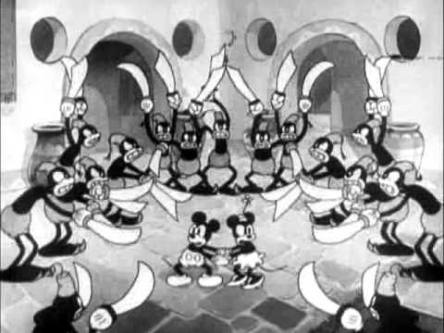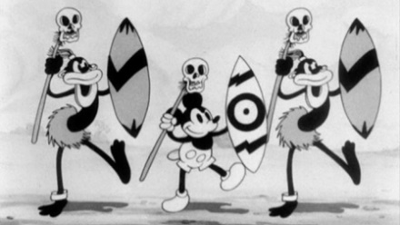The ideal of ‘the white man’s burden’ is obvious in cartoons set in either the states or beyond the mainland. Cartoons set in African countries, the inhabitants are ridiculously dark-skinned, intensely barbaric, and cannibalistic. These Africans are drawn with thick, heavy jewelry (gauges, anklets, necklaces, bracelets, nose rings and earrings), face paint, and grass skirts. These features are based on actual African cultures but are inflated to an extreme. By drawing these details to the extreme, the creator is merely implying that all Africans are uncultured, bizarre, and in need of humanizing. Not only are blacks seen as ‘strange creatures from a faraway place,’ they are also portrayed as savage. Usually in these episodes, the protagonist(s) finds themselves in an unknown landscape and is suddenly surrounded by native cannibals. The only way to escape this predicament, is to ‘educate’ the natives in proper etiquette or in more creative, less barbaric ventures (like Mickey teaching the natives the power of jazz music, seen in Figure 6).

Figure 8 In 'Mickey in Arabia', Mickey and Minnie find themselves in trouble of the country of Saudi Arbia, surrounded by sword-weilding locals..

Figure 7 Along with 'Jungle Jitters' in ‘Trader Mickey’, the titular mouse finds himself amid African cannibals and escapes such danger by teaching the cannibals jazz.

Figure 6a

Figure 6b

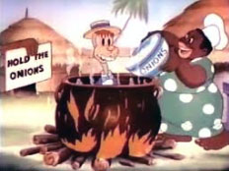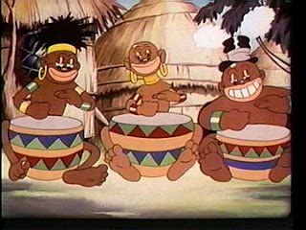And these are only examples of African-Americans. In “Mickey in Arabia,” the natives are also violent and sex-crazed and predatory, seen in Figure 7. During this time, between the late 1800’s and the mid-1900s, racism was a cultural norm in the United States. The treatment of racial minorities was justified by false claims of science and logic, and this mentality is displayed in these cartoons. There is a trend in the type of caricatures in these pieces; for example, early cartoons displayed black and native Americans as savage and cannibalistic, but as theses races were slowly integrated into society, the stereotypes transformed into blatant stupidity or lack of ambition. Also, the racial minorities began to change in cartoons; during World War II, cartoons began to focus less on blacks and more on Asians, Germans, and Italians. In Warner Bros.’ “*The Ducktators*,” Adolf Hitler, Benito Mussolini, and Hideki Tojo are portrayed as ‘Sieg Heil-ing’ ducks and geese. Hitler aggressively yells in German, Mussolini’s Italian accent is overplayed, and Tojo is slant-eyed, short, buck-toothed and butchers his English. *The Ducktators,* and other cartoons like it are propaganda against “the Other,” a general derogatory term used to explain ‘the enemy,’ whether it be in or on the outskirts of the United States. In 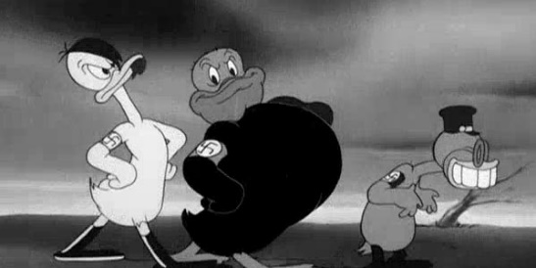Looney Toons’ “Tokio Jokio,” produced in WWII, Japanese people are portrayed as stupid. Bugs Bunny even participated in the exaggeration of Asians and Asian-Americans; in “Bugs Bunny Nips the Nips,” the witty bunny provokes the Japanese soldiers while in the jungle. They too are drawn with highly slanted eyes, buck-teeth, and speak poor, butchered, English. In general, the use of graphic imagery in cartoons is used to distinguish ‘us’ from ‘them.’ It is an attempt to dehumanize racial minorities buy cashing in on severe stereotypes under the guise of comedy and entertainment. These over-inflated images of racial stereotypes are a product of the time, but the ‘time’ being used here is one rooted in ignorance. To suggest that these images are only a product of the time, and therefore should be disregarded and forgotten entirely is like apathetically accepting it rather than learning from it.

Figure 6 a/b 'Jungle Jitters' is a prime example of the portrayal of African culture, and in turn, African-American.

Figure 9 Warner Bros. propaganda advertisement in 1942, complete with 'Aduck Hitler', 'Benito Goosilinni', and ‘Hiducki Tojo’.

Now that there is historical context in the US’s racist animation, the most important part of this analysis is what modern creators can learn from these cartoons, and what average viewers can gain from critically thinking about the media they consume. This does not mean slapping ‘the racist imagery’ sticker on every cartoon, but rather defining the line between satirical, unintentional, authentic racism.

The argument being made here is NOT denying anyone the right to laugh at offensive content; it is also NOT against freedom of speech, nor does it support the limitation of creative freedom and expression. The idea of ‘political correctness’ has made its mark in modern discourse, and not in a fully positive way. The suggestion being made here is to attempt to critically approach to the cartoons that are presented today, and that doing so has the potential to build positive audience perception/interpretation rather than negative ones. Not everything is truly racist, and not everyone will be offended by a joke, but recognizing individual perceptions means being able to understand the artist’s intent. The intent isn’t always to offend. Currently, it appears artists are trying to educate and empower their audience rather than ‘punch down (belittling the disadvantaged).’ This proposal of finding objective meaning in execrable content can be accomplished by defining the differences between ‘authentically offensive’ content and ‘satirically offensive’ content; in this case, ‘authentically versus satirically racist’ content.

*South Park*, *The Simpsons,* and *Family Guy are* modern cartoons known for their politically incorrect humor; sure, there are characters that are racist depictions of minorities, but their goal is to satirize the blatant stupidity of racists before them. They aren’t mocking blacks, Asians, Mexican, Native Americans to offend their audience; they are laughing at the absurdity of racism. For example, *Family Guy* makes hundreds, if not, thousands of jokes attacking people of all races and religions. In one episode, “Death has a Shadow,” a short scene is set up for the audience. A black guy (Harry) and a white guy (Mike) are in a bar, and the black character, Harry, tells the following joke; “So a horse walks into a bar, and the bartender says, ‘why the long face?’ Both men laugh, but the camera pans out to reveal an actual horse sitting next to them, getting highly offended because “Not everyone [the horse alluding to himself] can conform to your preconceived notions of attractiveness.” From there, both the men and the horse discuss the double standard of why one group can make fun of someone, but the other individual can’t due to preconceived notions of ‘racism.’ The point being that this is one example of many that use racism in their cartoons as a means for satirizing the stupidity of ignorant racism.

But not all cartoons are effective in social delivery. Unintentional racism is making subtle assumptions that are based on historical racism, and not considering the social ramifications of those overlooked details. A cartoon shown to a Virginia school district was banned for presenting “Structural Discrimination: The Unequal Opportunity Race.” The clip is an analogy for racial inequalities in the workplace, but parents and teachers found it more offensive than educational; parents claimed that it was a ‘white guilt video,’ because of the way the black characters were presented as incapable of success in the country than their white (more specifically, their white male) race competitors. According to Peter Holley, who reported this news story on Independent quotes “Luke Harris, co-founder of the African American Policy Forum and an associate professor of political science at Vassar College;” “Most of us know very little about the social history of the United States and its contemporary impact. It was designed as a tool to throw light on American history.” (Holley). This work had the intent on informing the public about racial disparities in America, but it came off as condescending, making its Caucasian audience feeling guilty for simply being white and supposedly ‘privileged.’ This is an example of unintentional racism, because the creators did not mean to offend their audience; they were trying to educate them on an important issue during Black History Month. ‘Authentic racism,’ like the cartoons from the 20th century, have the sole intent on dehumanizing a group. In cartoons, authentic racism is used to mock its subjects, satirical racism is used to mock racism, and unintentional racism is attempting to create an inoffensive work without realizing the possibility of accidentally offending an audience. For example,

Once viewers understand these subtle differences in types of racism in cartoons, they can better evaluate the media they watch without falling one only one side of the discussion. Not everyone is going to find something funny. Not everyone is going to be offended. If viewers understand the author’s intent of a work, it can drastically change the individual’s interpretation of the work itself. Growing up with cartoons, I never really took heavy notice into the racial depictions presented before me. That could be because I grew up in a more informed time, but even the cartoons I saw had their racial subtly. People argue that the King Louis and the orangutans in Disney’s *The Jungle Book* were inspired by black stereotypes, and that their singing and dancing was alluding to their history of jazz-and-jive culture. I, being like other kids at the time, never noticed it, but I can see where the argument comes into play. This same mentality goes for any group of crows, alluding to Jim Crow, or any large, sassy black lady who’s got a sharp tongue. These and other character’s like them didn’t have a negative interpretation to me, but there can be an argument as to why these archetypes, rooted in racial ignorance should cease to exist in the current century. A friend of mine, who is Mexican and part Native-American, never noticed the subtle racial undertones when re-watching the ‘What Makes the Red Man Red’ scene from *Peter Pan* ten years later. And my Asian friend, who recognizes the racial undertones in old cartoons, never thought much of it. Sure, our interpretations have a lot to do with the current events during our childhood, but one could argue that these interpretations have a lot more to them other than current events.

Art reflects the artist and their perspective on the world around them, but the viewer can be shaped by them in indirect ways. Of course, one could say that the jazzy singing monkeys and apes from *The Jungle Book* cartoon are racial stereotypes of black people; after all, the author of the book by the same name, Rudyard Kipling had his colonial-conquest sentiments. But in this cartoon adaption, the monkeys aren’t seen as extraordinarily dumb or illiterate like their historic predecessors. The song, “I Wanna Be Like You,” is a classic. That could be because of a change in audience interpretation. Rather than point and claim ‘racism,’ the audience can gain something more positive from the scene; they can dance and sing along to their cartoons. The famous Speedy Gonzales and his Mexican co-characters from the Merry Melodies shorts (Warner Bros.) were depicted as lazy, but once Warner Bros. removed the character from airing episodes, Mexican Americans petitioned to bring him back, because he was a great cartoon character that played on their TVs (Fitzpatrick). Mammy Two-Shoes from Tom and Jerry was originally written as a white family’s house-servant with an Ebonic dialect. Episodes still play on applications like Amazon Prime; a disclaimer is played before all showings because of the negative portrayal (Coughlan). With societal norms changing throughout time, the Eubonic dialect was replaced with a neutral, less offensive one. For the longest time, viewers, including myself, never took heavy offense to Mammy Two-Shoes, and in fact, assumed that she was the owner of the house where the titular cat and mouse reside in. Maybe the interpretations of these cartoons are a product of our less racist surroundings, but that form of open-minded habit when analyzing cartoons is one step closer to creating more meaningful, innovative, and socially evolved cartoons.

In conclusion, although society has altered its tune regarding racist depictions in its cartoons, it is still a prevalent subject matter in the industry and in modern culture. Animators and artists can learn from the racist history and create more witty, meaningful cartoons that can tackle adult themes like racism without having to walk on eggshells. Viewers can critically investigate the imagery they see in their media and can decide for themselves the takeaway they gain from the characters. The cultural significance of these cartoons is that the objective understanding and critiques of them can prevent the resurrection of more truly offensive content.

That’s all, folks! (Porky Pig)

# Works Cited

Coughlan, Sean. *Tom and Jerry Cartoons Carry Racism Warning*. BBC 1 October 2014. Online Article. 16 April 2018. http://www.bbc.com/news/education-29427843

Evans, Gavin. *The Unwelcome Revival of ‘Race Science’*. The Guardian 2 March 2018. Online Article. 22 April 2018. https://www.theguardian.com/news/2018/mar/02/the-unwelcome-revival-of-race-science

Ferfis State University's *Jim Crow Museum of Racist Memorabilia* . "Jim Crow Museum of Racist Memorabilia." n.d. Website. 16 April 2018. https://ferris.edu/HTMLS/news/jimcrow/index.htm

Fitzpatrick, Laura. "Top 10 Controversial Cartoons." Time 26 April 2010. Online Listicle . 16 April 2018. http://entertainment.time.com/2010/04/27/top-10-controversial-cartoons/slide/more-lists/

Gilbert, Sophie. "The Complicated Relevance of Dr. Seuss's Political Cartoons." The Atlantic 31 January 2017. Online Article. https://www.theatlantic.com/entertainment/archive/2017/01/dr-seuss-protest-icon/515031/

Holley, Peter. "Anger after students shown 'white guilt' cartoon for Black History Month." Independent 12 February 2016. Article with Video. https://www.independent.co.uk/news/world/americas/anger-after-students-shown-white-guilt-cartoon-for-black-history-month-a6869796.html#gallery

Kehr, Dave. *Animation*. Britannica 29 March 2018. Online Article. <https://www.britannica.com/art/animation>

Marschall, Richard. *The Tough Coughs As He Ploughs the Dough: Early Writing and Cartoons by Dr. Seuss*. New York: William Morrow And Company, Inc./Remco WorldService Books, 1987. Book.

Popova, Maria. "Before Walt Disney: 5 Pioneers of Early Animation." The Atlantic 5 July 2011. Online Article. https://www.theatlantic.com/entertainment/archive/2011/07/before-walt-disney-5-pioneers-of-early-animation/241448/